CTI110-Web Page Codes to Know – Copies of VSC/Web Pages etc -You name it
Do you have a list of the various codes along with their meanings Etc such as <hr> <br> etc, or a website
It’s always helpful to have a "cheat sheet" when you're starting out so you don't have to memorize everything. Here is a list of the most common codes you'll use in your WEB 110 class, along with their meanings:

Common HTML Tags Cheat Sheet
Tag | Name | What it does
<html> | Root | The "wrapper" for your entire webpage.
<head> | Head | Contains "invisible" info like the title and CSS styles.
<body> | Body | Contains everything the user actually sees.
<h1> to <h6> | Headings | Creates titles. <h1> is the biggest, <h6> is the smallest.
<p> | Paragraph | Used for regular blocks of text.
<a> | Anchor | Creates a link (use with href="URL").
<img> | Image | Displays a picture (use with src="filename.jpg").
<ul> | Unordered List | Creates a bulleted list.
<ol> | Ordered List | Creates a numbered list.
<li> | List Item | The actual item inside a list (bullets or numbers).
<hr> | Horizontal Rule | Creates a horizontal line to separate sections.
<br> | Break | Forces a line break (starts a new line without a gap).
<strong> | Strong | Makes text bold.
<em> | Emphasis | Makes text italic.
&&&&&&&&&&&&&&&&&&&&&&&&&&&&&&&&&&

Top 3 Recommended Websites for Students
If you ever forget a code, these three sites are the "gold standard" used by pros and students alike:
- W3Schools HTML Reference: The absolute best for beginners. It has a "Try It Yourself" button for every single tag so you can see it in action.
- MDN Web Docs (Mozilla): This is the "dictionary" of the internet. It’s a bit more detailed but very accurate.
- Codecademy HTML Glossary: A very clean, simple list of tags and what they do.

A Pro-Tip for your Homework:
Remember that tags like <hr> and <br> are "self-closing." This means they don't need a closing tag like </hr>. You just type them once and they work!
WEB 110 HTML Guide
HTML Tags for WEB 110 (WHW1) Page Structure - - - - - Text & Layout - - - - - - : Line Break (Forces text to the next line). - ©: Special character code for the Copyright symbol ©. Links & Images - : Anchor tag for links. - href: The destination (e.g., index.html or mailto:email). - target="_blank": Opens the link (like Google) in a new tab. - : Displays an image. - src: The filename (e.g., web.jpg). - alt: Text description if the image doesn't load. Lists & Tables - - - - - - Forms (Step 3 Specific) - - : Text label for an input. - for: Must match the id of the input it belongs to. - : A single-line box for names. - : Creates a dropdown menu. - - - - : Small circles for single-choice options. - - : Button to send the data. - : Button to clear all text in the form.
@@@@@@@@@@@@@@@@@@@@@@@@@@@@@@@@@@@@@@@@@@
Pin your important notes to the top.
WEB 110 HTML Guide

HTML Tags for WEB 110 (WHW1)
Page Structure

• `<!DOCTYPE html>`: Tells the browser this is an HTML5 document.

• `<html>`: The root element that wraps all your code.

• `<head>`: Contains metadata (title, styles) not visible on the page.

• `<title>`: Sets the name shown on the browser tab.

• `<body>`: Contains all visible content (headings, images, forms).

Text & Layout

• `#`: Main heading (Used for "This is the form page").

• `##` to ``: Subheadings for different sections.

• ``: Paragraph tag (Used for your Lorem Ipsum text).

• ``: Defines a set of navigation links.

• ``: Horizontal Rule (Creates the line separating your nav from your content).

• ` `: Line Break (Forces text to the next line).

• `&copy;`: Special character code for the Copyright symbol ©.

Links & Images

• ``: Anchor tag for links.

• `href`: The destination (e.g., `index.html` or `mailto:email`).

• `target="_blank"`: Opens the link (like Google) in a new tab.

• ``: Displays an image.

• `src`: The filename (e.g., `web.jpg`).

• `alt`: Text description if the image doesn't load.

Lists & Tables

• ``: Ordered List (Creates numbered items 1, 2, 3).

• **`**: List Item (Used inside ` or ``).

• `<table>`: Creates a table.

• `border="1"`: Adds visible lines around cells.

• ``: Table Row.

• ``: Table Header (Bold/centered text).

• ``: Table Data (Normal cell).

Forms (Step 3 Specific)

• `<form>`: Wraps all input elements.

• `<label>`: Text label for an input.

• `for`: Must match the `id` of the input it belongs to.

• `<input type="text">`: A single-line box for names.

• `<select>`: Creates a dropdown menu.

• `<option>`: An individual choice inside the dropdown.

• `<fieldset>`: Draws a box around related inputs (like radio buttons).

• `<legend>`: Provides a caption/title for the `<fieldset>`.

• `<input type="radio">`: Small circles for single-choice options.

• `<textarea>`: A large, multi-line box for comments.

• `<input type="submit">`: Button to send the data.

• `<input type="reset">`: Button to clear all text in the form.

Edited 5:03 PM
%%%%%%%%%%%%%%%%%%%%%%%%%%%%
here is one final question: How do you increase the size of the fonts in VSC??
There are two ways to do this in Visual Studio Code, depending on whether you want to zoom in on everything (including the sidebar and menus) or just make the code itself larger.

1. The "Quick Zoom" (Changes Everything)
This is the fastest way to make the whole interface easier to read. It scales the code, the sidebar, and the menu buttons all at once.
- Windows/Linux: Press Ctrl and + (the plus/equal key) to zoom in.
- Mac: Press Cmd and + to zoom in.
- To zoom out, use Ctrl / Cmd and - (the minus key).

2. The "Permanent Fix" (Changes Only the Code)
If your sidebar is fine but your code is too small, you should change the font size in your actual settings.
- Press Ctrl + , (comma) to open the Settings menu.
- In the search bar at the top, type "Font Size".
- Look for Editor: Font Size.
- Change the number (e.g., change 14 to 18 or 20). The change happens instantly!

3. The "Mouse Wheel" Trick (Optional)
If you like to zoom in and out quickly with your mouse, you can enable a hidden setting:
- Open Settings (Ctrl + ,).
- Search for "Mouse Wheel Zoom".
- Check the box for Editor: Mouse Wheel Zoom.
- Now, you can hold Ctrl and scroll your mouse wheel to grow or shrink your code instantly.
%%%%%%%%%%%%%%%%%%%%%%%
Samples of Homework ~ 3 Page Website 1/26/26
Index.html
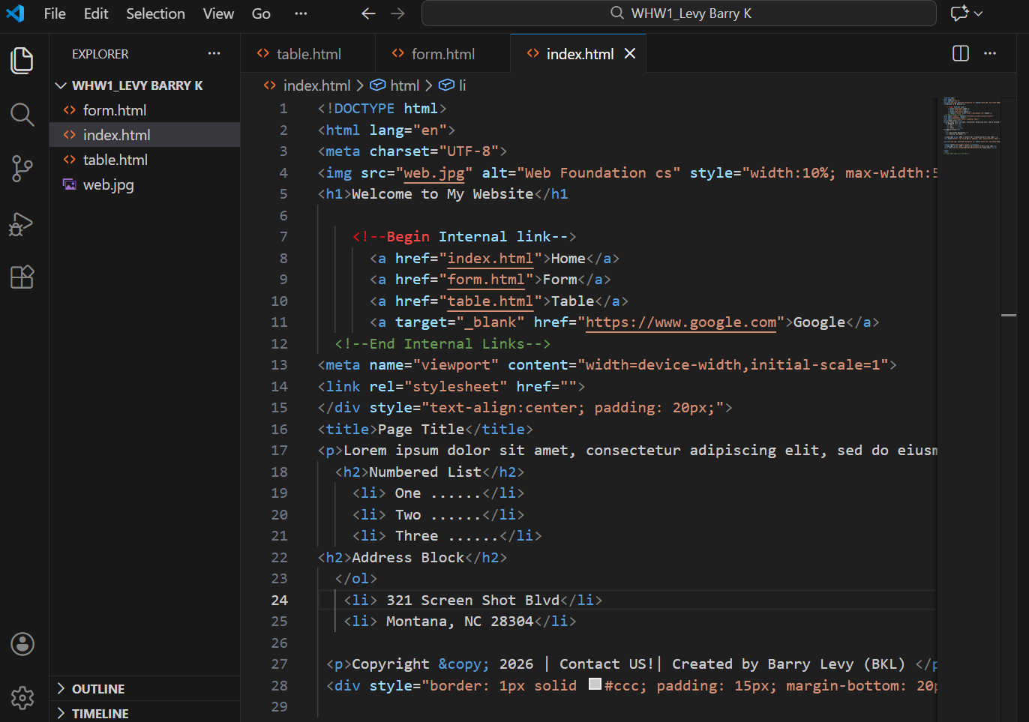
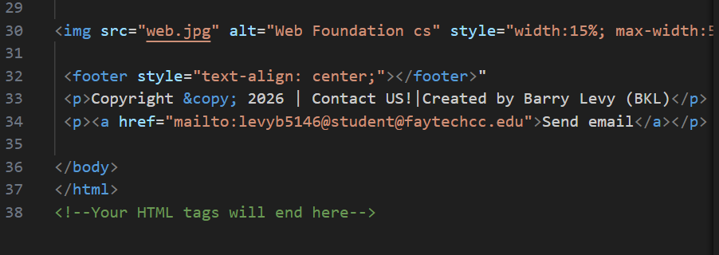
Table.html
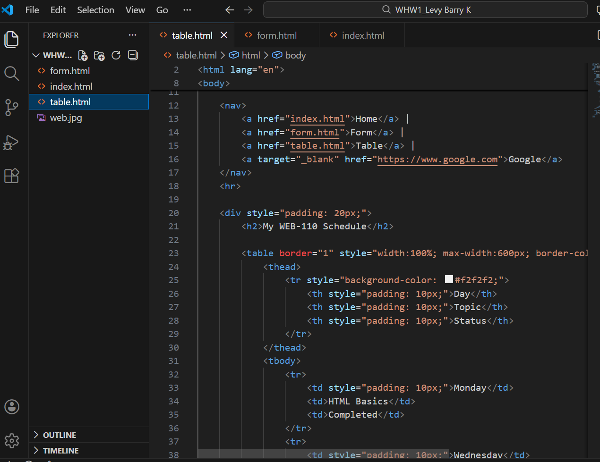
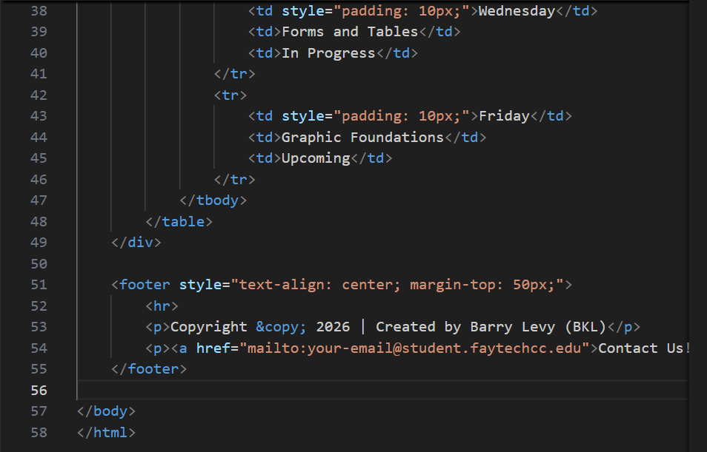
Form.html

